|  |  |  |  |
| --- | --- | --- | --- |
|  | | | |
| **AGRA FORT** | **FATEHPUR SIKRI** | **BIRLA TEMPLE** | **CITY PALACE** |
| **AMBER FORT** | **HAWA MAHAL** | **ELEPHANT RIDE AT AMBER FORT** | **AKSHARDHAM TEMPLE** |
| **JAMA MASJID** | **INDIA GATE** | **PRESIDENT HOUSE** | **PARLIAMENT HOUSE** |

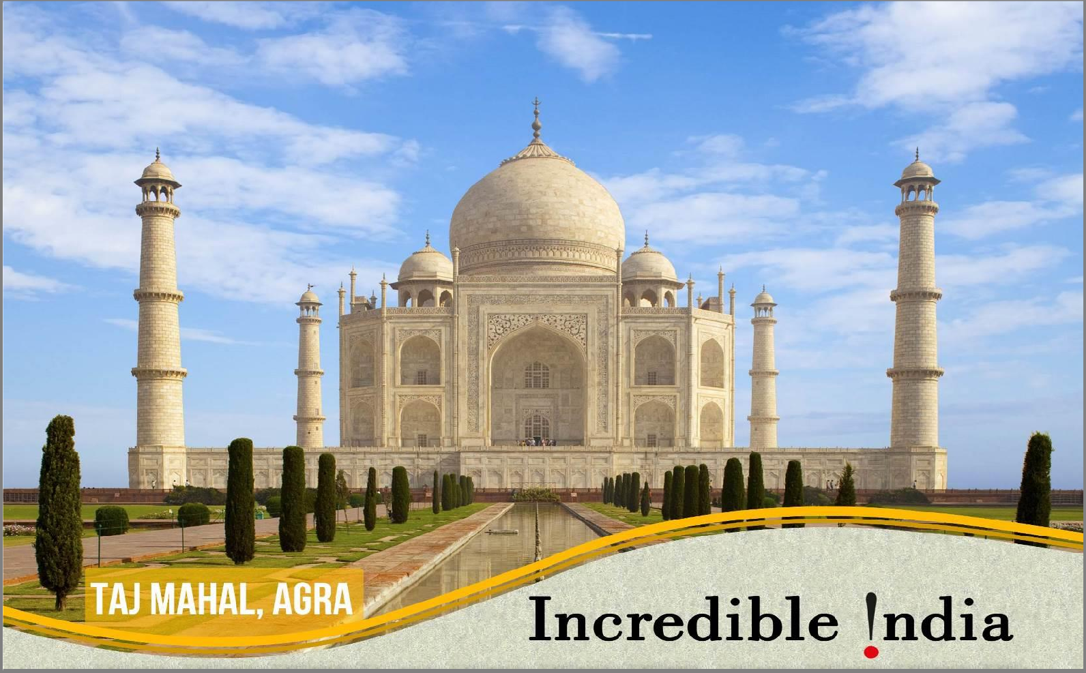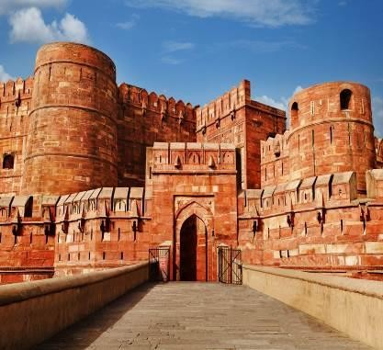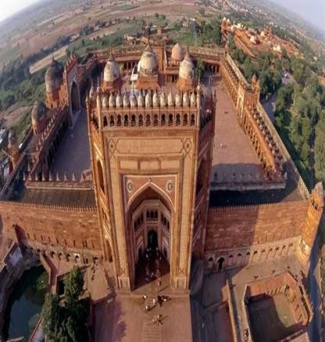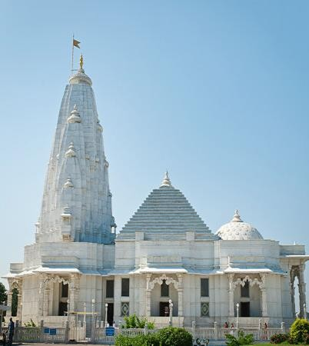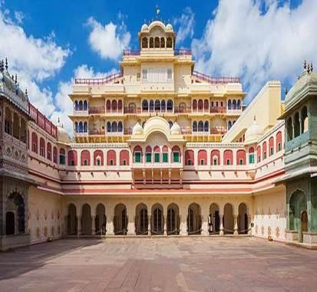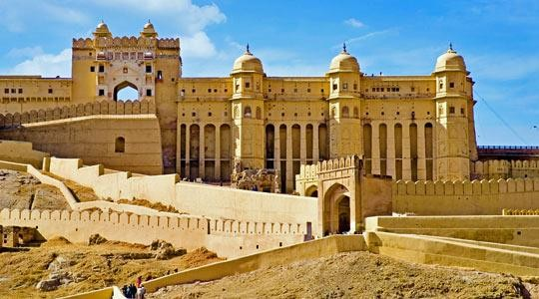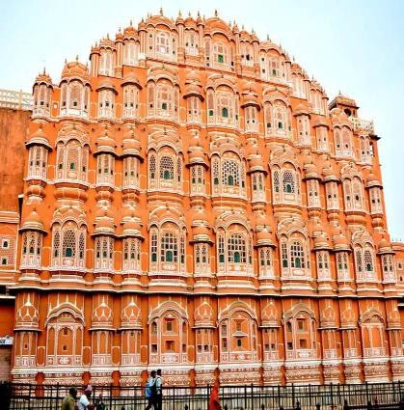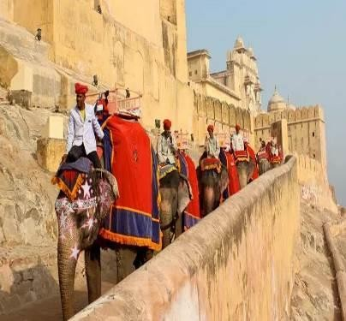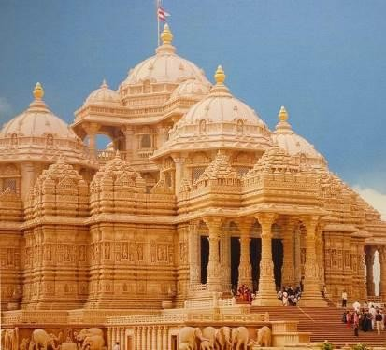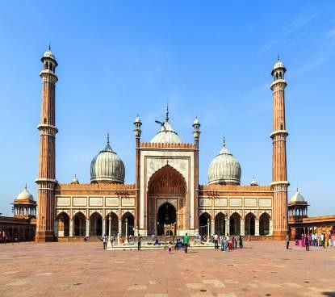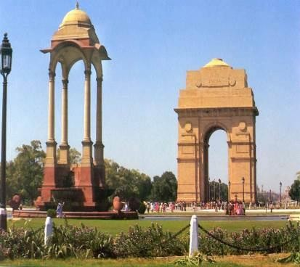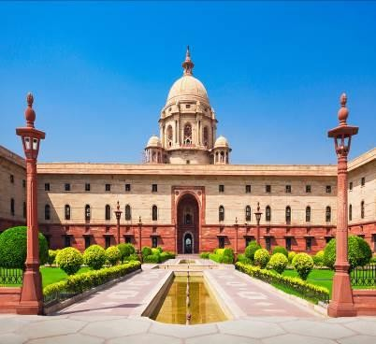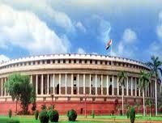

**GOLDEN TRIANGLE TOUR 04 NIGHTS / 05 DAYS**

**Destination covered: Delhi – Agra – Jaipur – Delhi**

**DAY 01: ARRIVAL DELHI (NO MEALS)**

Welcome on arrival by Travels & Tours representative at New Delhi Airport. After meet & assist services at the airport, transfer to Hotel. Overnight stay at Hotel in Delhi.

**DAY 02: DELHI – AGRA (B/L/D)**

Breakfast at hotel and then will drive to ward Agra (203 Kms / 4.5 Kms). On arrival, check in to the hotel and proceed sightseeing of Agra city tour visit one of the world’s most popular monument – **Taj Mahal** *(it is closed on every Friday)* built by Mughal Emperor Shah- Jehan for his Empress Mumtaj Mahal. The construction believed to have taken 22 years to complete with over 20,000 craft men working round the clock. Now proceed for sightseeing tour of magnificent **Agra Fort**- built at the bank of Yamuna River, is situated in the center of the town. Various styles of the architecture are evident within the fort & demonstrate the love of Mughal Emperors towards building beautiful monuments. Evening visit handicraft & textile industry and then visit Govt approve shops for souvenirs or gifts for friend or family, Agra is known for its fabulous marble-made handicrafts and soft stone inlay work. The Mughal were great patrons of arts and crafts. After that back to hotel for dinner and overnight stay.

**DAY 03: AGRA – JAIPUR (B/L/D)**

Breakfast at hotel and then will drive toward Jaipur – The Pink city (235kms, 5:30 Hrs.) Enroute visit **Fatehpur Sikri**- 37 kms from Agra. The deserted city of sandstone built by the Emperor. The city is rectangular in shape with nine huge gates & inside there are palaces, meeting halls (public/ private audiences), huge courtyards. On arrival, check-in at hotel and proceed for lunch at hotel. Late afternoon proceed to visit **Birla Temple** (Laxmi Narayan Temple) **-** is situated just below the Motinagri, known for the intricate marble carvings in white marble, popularly known as Birla Temple. **City Palace**- was the principle residence of the former ruling family and is known for its stunning architecture. It also includes museum, courtyards, and gardens. Back Dinner and Overnight in hotel.

**DAY 04: AT JAIPUR (B/L/D)**

Breakfast at hotel. Proceed for sightseeing visiting **Amer Fort** - 11 Kms from Jaipur is Amber, the ancient capital of Jaipur state construction of the Fort Palace was constructed in 1652 by Raja Mansingh and it was later extended & completed by the Jai Singh before the move to Jaipur. **Enjoy elephant ride while climbing up to the Amer Fort. Jal Mahal -** (6 kms) on the way to Amer, this small palace is set in the middle of Man Sagar Lake. Renovation around the lake is in progress. Back hotel for lunch. Afternoon visit **Hawa Mahal** (Palaces of the Wind) - a beautiful pink color building having many small windows from where the Royal Ladies watched the annual procession of kingdom. The tourist can take photograph from outside only. Jaipur is a city of vibrant colors and markets (bazaars) of Jaipur verify this fact. Jaipur's colorful markets offer a great break to stop and shop on you tour. Usually tourists include shopping and visiting the lively markets of Jaipur in their itinerary. While moving through the markets, you will come across the vivacious culture of this region. Jaipur is the perfect place to shop for Handicrafts, antiques, jewelry, gems, pottery, carpets, textiles, metal work and leather ware. Evening, we will back to hotel for dinner & overnight stay.

**DAY 05: JAIPUR – DELHI + DEPARTURE (B/L/D)**

Breakfast at Hotel. After breakfast drive to Delhi (265 km, 06 hrs). On arrival, transfer to a local restaurant for lunch. Afternoon proceeds to visit **Jama masjid -** One of the Architectural gift given by Shah Jahan, Jama Masjid is one of the largest mosques not only in Delhi but in India. Completed in 1658 this Mosque has three gateways, four angle towers and two 40 m high minarets. You can enter the mosque but take precaution to take off your shoes and make sure that you are properly dressed before entering. One can also go to the top of minarets. From here you can have a bird’s eye view of Delhi.

**India Gate**- at the centre of the city (42 meter, high stone arch) is a memorial raised in honour of the Indian soldiers who fought & died in the campaign of world war-1 & Afghan war, **President House**- built in 1929, once the Imperial residence of the British Viceroys and now official residence of the President of Indian Republic, **Parliament House** – this circular shaped building houses the two houses of Parliament- The **Lok Sabha** (lower) & **Rajya Sabha** (Upper). Its domed central hall is 90 feet in diameter. Evening proceed for dinner at a local restaurant and then transfer to airport to catch flight for home country.

**DAY 06: ARRIVE HOME COUNTRY**

Arrive home country with sweet memories.

**\*END OF TOUR* COST IS VALID FROM OCTOBER’ 2019 – MARCH’ 2020**

|  |  |  |  |  |  |
| --- | --- | --- | --- | --- | --- |
| ***QUOTATION AS UNDER:***  ***(USD PER PERSON)*** | ***04 NIGHTS / 05 DAYS GOLDEN TRIANGLE*** | | | | ***Type of vehicle to be***  ***used*** |
| ***3 STAR*** | ***4 STAR*** | ***5* LOCAL*** | ***5* DELUXE*** |
| Min paying pax 02 | *USD 377* | *USD 411* | *USD 451* | *USD 536* | Air-con car |
| Min paying pax 03 – 04 | *USD 348* | *USD 388* | *USD 433* | *USD 514* | Air-con Innova car |
| Min paying pax 05 – 07 | *USD 341* | *USD 381* | *USD 400* | *USD 491* | Air-con Van |
| Min paying pax 08 – 09 | *USD 309* | *USD 349* | *USD 389* | *USD 475* | Air-con Van |
| Min paying pax 10-14 + 00 FOC | *USD 304* | *USD 336* | *USD 380* | *USD 461* | Air-con Mini Coach |
| Paying pax 15 & onwards + 01 FOC | *USD 275* | *USD 306* | *USD 352* | *USD 432* | Air-con Large Coach |
| Single Room Supplement | *USD 95* | *USD 125* | *USD 167* | *USD 229* |  |

***\* FOC on Twin sharing basis***

**CHILD COST:**

0 - 5 Years - Free without any extra bed

05 years up to 12 years - 80% of adult cost with an extra bed.

05 years up to 12 years - 60% of adult cost without an extra bed. 12 years and above - Will be treated as adult.

**TOUR COST INCLUDES:**

* 04 Nights hotel accommodation based on twin room.
* All **meals** as per Itinerary (B/L/D)
* Air-conditioned Transport throughout the tour as per the itinerary.
* Monument Entrance + Elephant ride at Amer Fort in Jaipur.
* English speaking guide through out of tour for 5 pax onward, below 5 pax, we provide local spot guide.
* Arrival & Departure Assistance at Airport.
* All fuel charge, Toll taxes, Driver allowance, enter state taxes etc.
* Presently applicable government taxes.

**TOUR COST DOES NOT INCLUDE:**

* Any Air fare, airport departure tax etc.
* ***Telegraphic Transfer.*** *(Please kindly be inform most of the remitter bank are not including telegraphic transfer charges from sender as a result telegraphic charges are being deducted from the account of beneficiary)*
* ***If any taxes, entrances fee is being increased by concerned authorities, it will be informed you accordingly and it will be charge on actual.***
* ***Any surcharge for Christmas & New Year’s Eve.***
* Expenses of personal nature such as Laundry, telephone bill etc.
* Any Kinds of Tips.
* Other services not mentioned above.

**COMPLIMENTARY SERVICES:**

* Welcome Garland on Arrival
* 01 bottle of water per day per person

**HOTELS TO BE PROVIDED OR SIMILAR (SUBJECT TO AVAILABILITY ONLY)**

|  |  |  |  |  |
| --- | --- | --- | --- | --- |
| ***CITY*** | ***03 STAR*** | ***04 STAR*** | ***05 STAR LOCAL*** | ***05 STAR DELUXE*** |
| **DELHI** | [Hotel Golden Tulip](http://www.goldentulipwestdelhi.com/) [Essential](http://www.goldentulipwestdelhi.com/) / [Clarks](http://bhtgroup.org/Hotel/Clarks-Inn-Suites--Kapashera--New-Delhi/19) [Inn Kapashera](http://bhtgroup.org/Hotel/Clarks-Inn-Suites--Kapashera--New-Delhi/19) / Similar | [Hotel LA](https://www.la-delhi.com/) / [Glitz](http://glitzwestendinn.com/) [Westend](http://glitzwestendinn.com/) / [Piccadily](http://www.piccadilyhotels.com/contact-us.php)  / Similar | [Piccadilly](http://www.piccadilyhotels.com/contact-us.php)/ [Country inn](https://www.countryinns.com/ghaziabad-hotel-in-201010/indsahi?s_cid=os.apac-IN-cis-INDSAHI-gmb) [Suites](https://www.countryinns.com/ghaziabad-hotel-in-201010/indsahi?s_cid=os.apac-IN-cis-INDSAHI-gmb) / Similar | [Radisson Blu](https://www.radissonblu.com/en/hotel-newdelhipaschimvihar?s_cid=os.apac-IN-blu-INDRDPV-gmb) [Paschim Vihar](https://www.radissonblu.com/en/hotel-newdelhipaschimvihar?s_cid=os.apac-IN-blu-INDRDPV-gmb) / [ITC](https://www.itchotels.in/hotels/new-delhi/welcomhoteldwarka.html?utm_source=google&amp;utm_medium=organic%20Search&amp;utm_term=WelcomHotel-Dwarka&amp;utm_campaign=listing) [Dwarka](https://www.itchotels.in/hotels/new-delhi/welcomhoteldwarka.html?utm_source=google&amp;utm_medium=organic%20Search&amp;utm_term=WelcomHotel-Dwarka&amp;utm_campaign=listing) / [Radisson](https://www.radissonblu.com/en/hotel-newdelhidwarka?facilitatorId=CSOSEO&amp;csref=org_gmb_sk_en_sn_ho_INDRBDW) [Dwarka](https://www.radissonblu.com/en/hotel-newdelhidwarka?facilitatorId=CSOSEO&amp;csref=org_gmb_sk_en_sn_ho_INDRBDW) / [Crown](https://www.ihg.com/crowneplaza/hotels/us/en/new-delhi/delba/hoteldetail?cm_mmc=GoogleMaps-_-CP-_-IN-_-DELBA)  [plaza Rohini](https://www.ihg.com/crowneplaza/hotels/us/en/new-delhi/delba/hoteldetail?cm_mmc=GoogleMaps-_-CP-_-IN-_-DELBA) Similar |
| **AGRA** | [Hotel Siris 18](https://www.siris18.com/)/ [Hotel Amar](http://www.hotelamar.com/)/ [Hotel](http://www.hotelkant.in/) [Kant](http://www.hotelkant.in/) / Similar | [Howard Plaza](http://www.howardplazaagra.com/) / [PL](http://www.lordshotels.com/lords-inn-agra/) [Palace Lords Inn](http://www.lordshotels.com/lords-inn-agra/)/  [Royale Regenta](https://www.hotelroyaleregent.com/) / Similar | [Clarks Shiraz](http://www.hotelclarksshiraz.com/) / [Ramada](http://www.ramadaplazaagra.com/)/ [Hotel Mansingh Palace](http://www.mansinghhotels.com/)  /Similar | [Jaypee Palace](http://www.jaypeehotels.com/convention-center-agra) / [Radisson East Gate](https://www.radissonblu.com/en/hotel-agra?s_cid=os.apac-IN-blu-INDATEG-gmb)  / [Hilton](http://doubletree3.hilton.com/en/hotels/india/doubletree-by-hilton-hotel-agra-AGRDTDI/index.html?WT.mc_id=zELWAKN0APAC1DT2DMH3LocalSearch4DGGenericx6AGRDTDI) /Similar |
| **JAIPUR** | [Hotel Fort](http://www.fortchandragupt.com/) [Chandragupta](http://www.fortchandragupt.com/) / [Hotel Red Fox](https://www.lemontreehotels.com/red-fox-hotel/jaipur/hotels-jaipur.aspx) /  Similar | [K.K Royal](http://www.kkjaipur.com/) / [Libra](http://www.librahoteljaipur.com/) / [Gold Palace](http://www.hotelgoldpalace.com/) / [Crimson Park](https://www.crimson-park.com/) /  Similar | [Clarks Amer](http://www.hotelclarks.com/amer-jaipur/) / [Golden](http://www.goldentulipjaipur.com/) [Tulip](http://www.goldentulipjaipur.com/) / [Hotel Fortune](https://www.fortunehotels.in/jaipur-fortune-select-metropolitan.dh.41) [Select Metropolitan](https://www.fortunehotels.in/jaipur-fortune-select-metropolitan.dh.41) /  [Mansingh palace](http://www.mansinghhotels.com/)/ Similar | [Hilton Hotel](http://www3.hilton.com/en/hotels/india/hilton-jaipur-JAIGHHI/index.html?WT.mc_id=zELWAKN0APAC1HI2DMH3LocalSearch4DGGenericx6JAIGHHI) / [Crown Plaza](https://www.ihg.com/crowneplaza/hotels/us/en/jaipur/jaitr/hoteldetail?cm_mmc=GoogleMaps-_-CP-_-IN-_-JAITR) / Similar |

**IMP NOTE:** In case the Hotel envisaged or normal category of Rooms are waitlisted / sold out, alternate hotels/category will be provided & we will keep you informed on the supplement / reduction involved.